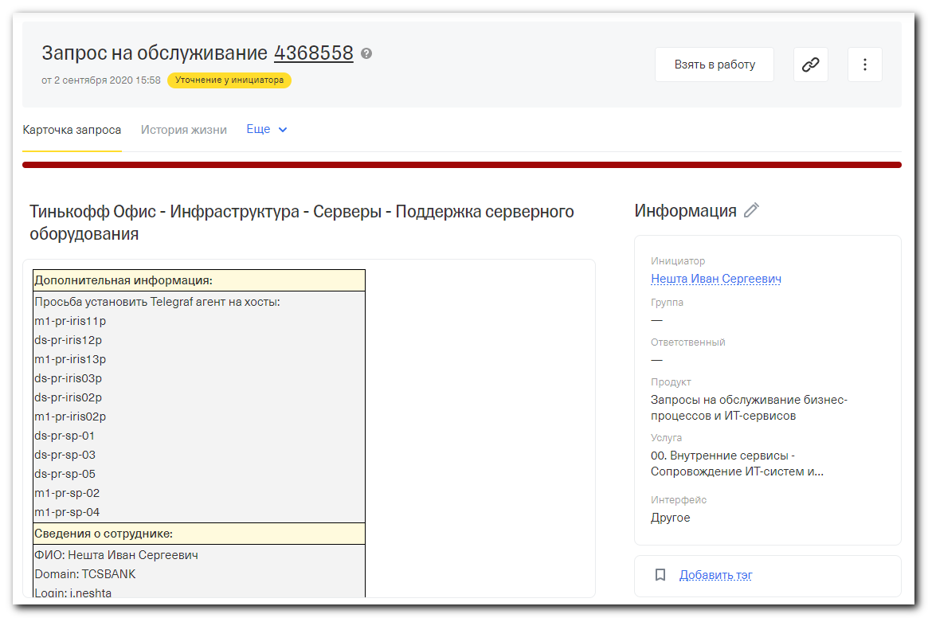
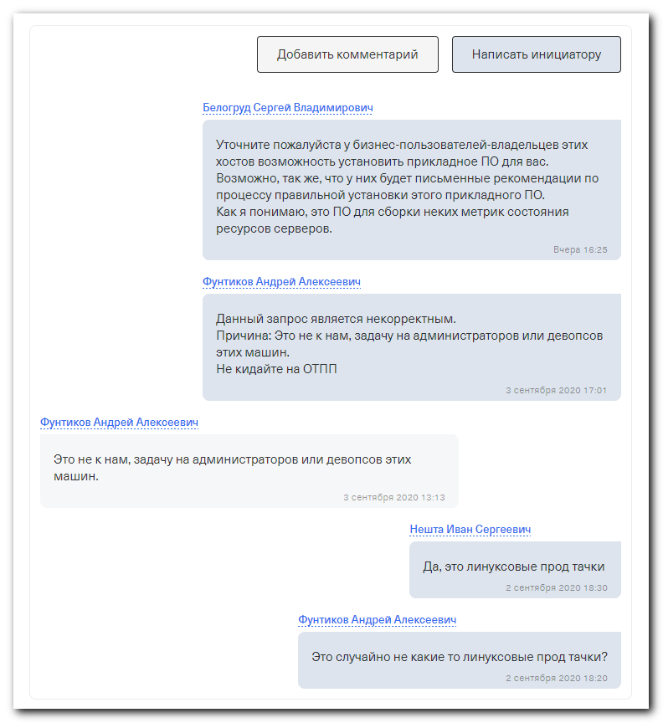

#
# As I undestood, the telegraf client config is same for, at least two servers. So I suppose, that it’s similar for everyone.
#

[root@ds-pr-iris12p ~]# cat > /etc/telegraf/telegraf.conf
[global_tags]
[agent]
interval = "10s"
round_interval = true
metric_batch_size = 1000
metric_buffer_limit = 10000
collection_jitter = "0s"
flush_interval = "10s"
flush_jitter = "0s"
precision = ""
debug = false
quiet = false
logfile = ""
hostname = ""
omit_hostname = false
[[outputs.influxdb]]
urls = ["http://m1-metrics01p.tcsbank.ru:8086"]
[[inputs.cpu]]
percpu = true
totalcpu = true
collect_cpu_time = false
report_active = false
[[inputs.disk]]
ignore_fs = ["tmpfs", "devtmpfs", "devfs"]
[[inputs.diskio]]
[[inputs.kernel]]
[[inputs.mem]]
[[inputs.processes]]
[[inputs.swap]]
[[inputs.system]]
[[inputs.kernel_vmstat]]
[[inputs.linux_sysctl_fs]]
[[inputs.net]]
[[inputs.netstat]]
[[inputs.nstat]]
[root@ds-pr-iris12p ~]#

# These servers have same configuration.
m1-pr-iris11p
ds-pr-iris12p
m1-pr-iris13p
ds-pr-iris03p
ds-pr-iris02p
m1-pr-iris02p
ds-pr-sp-01
ds-pr-sp-03
ds-pr-sp-05
m1-pr-sp-02
m1-pr-sp-04

[root@ds-pr-iris12p ~]# rpm -qi telegraf
package telegraf is not installed
[root@ds-pr-iris12p ~]#

[root@ds-pr-iris12p ~]# yum repolist
Loaded plugins: etckeeper, langpacks, product-id, search-disabled-repos, subscription-manager
This system is not registered with an entitlement server. You can use subscription-manager to register.
Repodata is over 2 weeks old. Install yum-cron? Or run: yum makecache fast
repo id repo name status
!epel/x86_64 Extra Packages for Enterprise Linux 7 - x86_64 13,194
!puppetlabs-deps/x86_64 Puppet Labs Dependencies El 7 - x86_64 17
!puppetlabs-products/x86_64 Puppet Labs Products El 7 - x86_64 225
!rhel-7-server-rpms/7Server/x86_64 Red Hat Enterprise Linux 7 Server (RPMs) 28,596
!tcs-dell-dsu-os_dependent DSU-OS-DEP 275
!tcs-dell-dsu-os_independent DSU-OS-INDEP 21,476
repolist: 63,783
[root@ds-pr-iris12p ~]# yum clean all
Loaded plugins: etckeeper, langpacks, product-id, search-disabled-repos, subscription-manager
This system is not registered with an entitlement server. You can use subscription-manager to register.
Repodata is over 2 weeks old. Install yum-cron? Or run: yum makecache fast
Cleaning repos: epel puppetlabs-deps puppetlabs-products rhel-7-server-rpms tcs-dell-dsu-os_dependent tcs-dell-dsu-os_independent
Cleaning up everything
Maybe you want: rm -rf /var/cache/yum, to also free up space taken by orphaned data from disabled or removed repos
[root@ds-pr-iris12p ~]#

[root@ds-pr-iris12p ~]# yum repolist
Loaded plugins: etckeeper, langpacks, product-id, search-disabled-repos, subscription-manager
This system is not registered with an entitlement server. You can use subscription-manager to register.
tcs-influxdb | 2.5 kB 00:00:00
tcs-influxdb/primary_db | 49 kB 00:00:00
repo id repo name status
epel/x86_64 Extra Packages for Enterprise Linux 7 - x86_64 13,441
puppetlabs-deps/x86_64 Puppet Labs Dependencies El 7 - x86_64 17
puppetlabs-products/x86_64 Puppet Labs Products El 7 - x86_64 225
rhel-7-server-rpms/7Server/x86_64 Red Hat Enterprise Linux 7 Server (RPMs) 32,691
tcs-dell-dsu-os_dependent DSU-OS-DEP 316
tcs-dell-dsu-os_independent DSU-OS-INDEP 39,801
tcs-influxdb tcs-influxdb 202
repolist: 86,693
[root@ds-pr-iris12p ~]#

................................................................................

[root@ds-pr-iris12p ~]# yum install telegraf
Loaded plugins: etckeeper, langpacks, product-id, search-disabled-repos, subscription-manager
This system is not registered with an entitlement server. You can use subscription-manager to register.
Resolving Dependencies
--> Running transaction check
---> Package telegraf.x86_64 0:1.15.2-1 will be installed
--> Finished Dependency Resolution

Dependencies Resolved

=======================================================================================================================================================================================
Package Arch Version Repository Size
=======================================================================================================================================================================================
Installing:
telegraf x86_64 1.15.2-1 tcs-influxdb 20 M

Transaction Summary
=======================================================================================================================================================================================
Install 1 Package

Total download size: 20 M
Installed size: 20 M
Is this ok [y/d/N]: y
Downloading packages:
telegraf-1.15.2-1.x86_64.rpm | 20 MB 00:00:00
Running transaction check
Running transaction test
Transaction test succeeded
Running transaction
etckeeper: pre transaction commit
Installing : telegraf-1.15.2-1.x86_64 1/1
Created symlink from /etc/systemd/system/multi-user.target.wants/telegraf.service to /usr/lib/systemd/system/telegraf.service.
etckeeper: post transaction commit
Verifying : telegraf-1.15.2-1.x86_64 1/1

Installed:
telegraf.x86_64 0:1.15.2-1

Complete!
[root@ds-pr-iris12p ~]#

................................................................................

[root@ds-pr-iris12p ~]# mkdir -p ~/work/20200908-1809
[root@ds-pr-iris12p ~]# cp /etc/telegraf/telegraf.conf ~/work/20200908-1809/
[root@ds-pr-iris12p ~]#

[root@ds-pr-iris12p ~]# systemctl stop telegraf
[root@ds-pr-iris12p ~]# cat > /etc/telegraf/telegraf.conf
[global_tags]
[agent]
interval = "10s"
round_interval = true
metric_batch_size = 1000
metric_buffer_limit = 10000
collection_jitter = "0s"
flush_interval = "10s"
flush_jitter = "0s"
precision = ""
debug = false
quiet = false
logfile = ""
hostname = ""
omit_hostname = false
[[outputs.influxdb]]
urls = ["http://m1-metrics01p.tcsbank.ru:8086"]
[[inputs.cpu]]
percpu = true
totalcpu = true
collect_cpu_time = false
report_active = false
[[inputs.disk]]
ignore_fs = ["tmpfs", "devtmpfs", "devfs"]
[[inputs.diskio]]
[[inputs.kernel]]
[[inputs.mem]]
[[inputs.processes]]
[[inputs.swap]]
[[inputs.system]]
[[inputs.kernel_vmstat]]
[[inputs.linux_sysctl_fs]]
[[inputs.net]]
[[inputs.netstat]]
[[inputs.nstat]]
[root@ds-pr-iris12p ~]# systemctl start telegraf
[root@ds-pr-iris12p ~]# systemctl enable telegraf
[root@ds-pr-iris12p ~]# systemctl status telegraf
в—Џ telegraf.service - The plugin-driven server agent for reporting metrics into InfluxDB
Loaded: loaded (/usr/lib/systemd/system/telegraf.service; enabled; vendor preset: disabled)
Active: active (running) since Tue 2020-09-08 18:10:48 MSK; 9s ago
Docs: https://github.com/influxdata/telegraf
Main PID: 13962 (telegraf)
CGroup: /system.slice/telegraf.service
в””в”Ђ13962 /usr/bin/telegraf -config /etc/telegraf/telegraf.conf -config-directory /etc/telegraf/telegraf.d

Sep 08 18:10:48 ds-pr-iris12p.tcsbank.ru systemd[1]: Started The plugin-driven server agent for reporting metrics into InfluxDB.
Sep 08 18:10:48 ds-pr-iris12p.tcsbank.ru systemd[1]: Starting The plugin-driven server agent for reporting metrics into InfluxDB...
Sep 08 18:10:48 ds-pr-iris12p.tcsbank.ru telegraf[13962]: 2020-09-08T15:10:48Z I! Starting Telegraf 1.15.2
Sep 08 18:10:48 ds-pr-iris12p.tcsbank.ru telegraf[13962]: 2020-09-08T15:10:48Z I! Loaded inputs: cpu disk system diskio kernel mem processes swap kernel_vmstat linux_sysc...stat nstat
Sep 08 18:10:48 ds-pr-iris12p.tcsbank.ru telegraf[13962]: 2020-09-08T15:10:48Z I! Loaded aggregators:
Sep 08 18:10:48 ds-pr-iris12p.tcsbank.ru telegraf[13962]: 2020-09-08T15:10:48Z I! Loaded processors:
Sep 08 18:10:48 ds-pr-iris12p.tcsbank.ru telegraf[13962]: 2020-09-08T15:10:48Z I! Loaded outputs: influxdb
Sep 08 18:10:48 ds-pr-iris12p.tcsbank.ru telegraf[13962]: 2020-09-08T15:10:48Z I! Tags enabled: host=ds-pr-iris12p.tcsbank.ru
Sep 08 18:10:48 ds-pr-iris12p.tcsbank.ru telegraf[13962]: 2020-09-08T15:10:48Z I! [agent] Config: Interval:10s, Quiet:false, Hostname:"ds-pr-iris12p.tcsbank.ru", Flush Interval:10s
Hint: Some lines were ellipsized, use -l to show in full.
[root@ds-pr-iris12p ~]#

................................................................................

